D. BERRIN GUNAYDIN, MD, PhD
ACADEMIC HISTORY
2007- | Professor at Department of Anesthesiology & Reanimation, Gazi University School of Medicine
2002-2007 | Associate Professor at Department of Anesthesiology & Reanimation, Gazi University School of Medicine
2000-2002 | Assistant Professor at Department of Anesthesiology & Reanimation, Gazi University School of Medicine
1994-2000 | PhD in Pharmacology at Department of Pharmacology, Gazi University School of Pharmacy
1989-1994 | Residency at Department of Anesthesiology & Reanimation, Gazi University School of Medicine
1983-1989 | Medical Degree at Ankara University School of Medicine

INTERNATIONAL EXPERIENCES
1998 June-July | Visiting Fellow at Department of Anesthesiology, Heart Institute of Japan, Tokyo Women’s Medical University, Tokyo, Japan
1991-1992 | Visiting Trainee/fellow at Department of Anesthesiology, Academical Medical Center, University of Amsterdam, The Netherlands

CERTIFICATIONS
2003 December | Problem Based Learning (PBL) Instructor Course organized by Ankara University Faculty of Medicine, Turkey
2003 October | Teach the Teachers Course organized by Gazi University, Ankara, Turkey
2005 December | Rational Pharmacotherapy Workshop organized by Dalhousie University, Canada
2006 June | Rational Pharmacotherapy Instructor Course organized by Gazi University Faculty, Ankara, Turkey
2011 February | Evidenced Based Medicine Instructor Course organized by Gazi University, Ankara, Turkey
2019 February | Basic Good Clinical Practice Course (online) organized by the Society of Clinical Trials, Ankara, Turkey
2020 June | Advanced Good Clinical Practice Course (online) organized by the Society of Clinical Trials, Ankara, Turkey
2023 November | Focus Meeting on Perioperative Medicine - Brain (online) organized by ESAIC
2024 February | Advanced Patient Safety Course organized by ESAIC in Istanbul, Turkey
POSITIONS OF RESPONSIBILITY WITHIN THE;
- ACADEMIC JOURNALS
2014- | Editorial Board Member of Turkish Journal of Clinics and Laboratory
2010- | Associate Editor of Turkish Journal of Medical Sciences
2018-2020 | Obstetric Anesthesia Section Editor of Turkish Journal of Anesthesiology & Reanimation
2020-2022 | Associate Editor of Turkish Journal of Anesthesiology & Reanimation
2020- | Editorial board member of BMC Anesthesiology
- TURKISH SOCIETY OF ANESTHESIOLOGY AND REANIMATION
2015-2023 | Chairperson of the Obstetric Anesthesia Subcommittee Prepared Practice Guidelines for Cesarean Section under Neuraxial & General Anesthesia http://www.tard.org.tr/akademi/?p=kilavuz&session=11465496755032-22930993510064  Webinars  - Updates in Obstetric Anesthesia & POCUS (September 18, 2021)  - Multidisciplinary Approach to Uterotonics (December 22, 2022)  Workshop  - Neuraxial Labor Analgesia at Kartal Education Research Hospital (May 27, 2022).  Launched guidelines and protocols at https://akademi.tard.org.tr  - Updated Obstetric Anesthesia Practice Guidelines in 2023 https://akademi.tard.org.tr/?p=kilavuz-detay&bID=44&session=67731983u203195949s338659916  b) Published online Updated Anesthesia Protocol for Cesarean Section in 2021 https://akademi.tard.org.tr/?p=kilavuz-detay&bID=40&session=67731983u203195949s338659916  c) Published E-book of Neuraxial Analgesia Guideline for Vaginal Delivery in 2017.  https://akademi.tard.org.tr/?p=kilavuz-detay&bID=27&session=67731983u203195949s338659916
2013-2021 | Vice Chair of the Obstetric Anesthesia education (Module IV: Mother & Child Anesthesia)  for trainees affiliated by the Committee of European Education in Anesthesiology (CEEA)  Organized regular education modules twice a year available at; http://www.tard.org.tr/akademi/?p=modul-detay&bID=4&session=11465496755032-22930993510064  Co-organiser for modules in 2014, 2015, 2016, 2017, 2018, 2019 and 2020
2021- | Chairperson of the Obstetric Anesthesia education (Module IV: Mother & Child Anesthesia) for trainees affiliated by the CEEA  Organized 2 online modules in 2022 and 2023

2019 Coordinated her department’s 1st Online Trainee Assessment organized by TSAR

- EUROPEAN SOCIETY OF ANAESTHESIOLOGY AND INTENSIVE CARE (ESAIC)
- National Coordinator of Multicenter Study EPIMAP (European Practices in the Management of Accidental dural Puncture in Obstetrics 2015-2017) http://www.esahq.org/~/media/ESA/Files/ClinicalTrialNetwork/EPiMAP/News%20Centre/EPiMAP_Call%20for%20Centre%202016-July-07.ashx
- National Coordinator of Multicenter Study MaCriCare (Maternal Critical Care) https://macricare.org/units.html
- National Coordinator of Multicenter Study ACCESS (Anesthesia PraCtice for Cesarean DElivery Snapshot Study) www.access-study.org
- Investigator, ALICE (Assessing the preoperative anaemia prevalence in surgical patients)
- Investigator, EPISAKI (EPIdemiology of Surgery-Associated Acute Kidney Injury).
- TEP Host
- OLA/HOLA Host (hosted twice in 2019 and 2021)

- DEPARTMENT OF ANESTHESIOLOGY AND REANIMATION
2017-2023 | Authorized Deputy of Accreditation Task Force in Anesthesiology and Reanimation Training in Gazi University recognized by European Society of Anaesthesiology (ESA-HVTAP) available at;  https://www.esahq.org/education/hospital-visiting-and-training-accreditation-program/hvtap-news/
2023- | Authorized Deputy of Accreditation Task Force in Anesthesiology and Reanimation Training in Gazi University recognized by European Society of Anaesthesiology and Intensive Care (ESAIC-ATAIC)
5) GAZI UNIVERSITY SCHOOL OF MEDICINE - Active involvement in teaching/mentoring
2010-2014 | Accreditation Task Force Member of Medical Education Curriculum (Graduate Level)
 | - Analyzed the current curriculum and academic program to give a report
2006-2009 | Vice Coordinator of Education of Clinical Skills (Graduate Level)  - Prepared 1st Guide on Clinical Skills Education (e.g. IV/IM injection etc.) available at;
 | http://med.gazi.edu.tr/posts/view/title/clinical-skills-education-guide-190017?siteUri=med
2004-2007 | Vice Coordinator of Continuing Medical Education (CME)(Postgraduate Level)
 | - Launched an orientation program with CPR course for incoming trainees for the 1st time at the Gazi University School of Medicine in 2005, then in 2006 and 2007.
2000-2004 | Coordinator for the 4th year students in the Gazi University School of Medicine scheduled/organized lectures, exam dates, and internships

MENTORSHIP/SUPERVISION
MENTORSHIP/SUPERVISION FOR TRAINEES/FELLOWS IN ABROAD/FROM ABROAD
Dr. Ece Tan Dumanlar | University of British Columbia, Department of Anesthesiology in Vancouver, Canada, 2007 | 2007 | Obstetric Anesthesiology
Dr. Selin Erel | United Kingdom, London  West Middlesex University Hospital | ERASMUS 2016 | Obstetric Anesthesiology
Dr. Naciye Türk Ozterlemez | Spain, Madrid  Rota in La Paz University Hospital | ERASMUS 2018 | Obstetric Anesthesiology
VISITING FELLOWS FROM ABROAD
Dr. Shakeel Ahmed | Aga Khan University  Karachi, Pakistan | August 2015 | Obstetric Anesthesiology
Dr.Nazuha Najid | Hospital Sultan Abdul Halim  Sungai Petani, Kedah, Malaysia | In 2018  for 9 months | Obstetric Anesthesiology
Dr. Abdul Rahim Rahimah | Hospital Tunku Azizah,  Kuala Lumpur, Malaysia | In 2022 for 9 months | Obstetric Anesthesiology

AWARDS

1)2004 Novartis’ Pharmacology Research Award on Antioxidant Activity of Local Anesthetic Drugs
Authors | Title | Published in Journal
Gunaydin B, Demiryürek AT | Effects of tetracaine and bupivacaine on chemiluminescence generated by formyl-methionyl-leucyl-phenylalanine-stimulated human leukocytes and cell-free systems. | Int Immunopharmacol 2003;3(5):757-64.
Gunaydin B, Demiryürek AT | Interaction of lidocaine with reactive oxygen and nitrogen species. | Eur J Anaesthesiol 2001;18(12):816-22.
Gunaydin B, Demiryürek AT | Effects of prilocaine and articaine on human leucocytes and reactive oxygen species in vitro. | Acta Anaesthesiol Scand 2001;45(6):741-5.
2)Free Paper Award at Resident’s Forum, 39th Annual Meeting of SOAP, May 16-19, 2007, Banff, Canada
Gunaydin B, Tan E | Intrathecal hyperbaric or isobaric bupivacaine and ropivacaine with fentanyl for elective caesarean section. | J Matern Fetal Neonatal Med 2010;23(12):1481-6.
3)Young Teaching Recognition Award at Euroanaesthesia 2017 Meeting organized by European Society of Anaesthesiologists (ESA) in Geneva, Switzerland
Erel S (Mentor:Gunaydin B) | Neuraxial analgesia for labour: standard versus novel approach | Published initially in ESA Newsletter issue 71  Then, in J Anesth 2019;33(1):125-30.  How neuraxial labor analgesia differs by approach: dural puncture epidural as a novel option. doi: 10.1007/s00540-018-2564-y.  JARSS 2017; 25(3): 113-6.
4) Best E-poster Award at the 51st Annual Meeting of Turkish Society of Anesthesiology and Reanimation in Antalya, 2017.
Duruk Erkent F  (coworkers: Gunaydin B, Erdogan M, Kalkanci A) | Antimicrobial Activity of Long Acting Local Anaesthetics

MENTORED THESES at http://www.websitem.gazi.edu.tr/site/gunaydin/posts/view/id/109259
Original Cover Page | Title and Authors | Status
T.C. GÜTF  ANESTEZİYOLOJİ VE REANİMASYON  ANABİLİM DALI  PREEKLAMPSİLİ GEBELERİN ANESTEZİ YÖNETİMİNDE AKCİĞER ULTRASONU BULGULARININ TANINMASINDA YAPAY ZEKA UYGULAMALARININ ETKİNLİĞİNİN DEĞERLENDİRİLMESİ  UZMANLIK TEZİ  DR. SELİN BAĞCAZ  TEZ DANISMANI  PROF. DR. BERRİN GÜNAYDIN  ANKARA  2022 | Evaluation of Artificial Intelligence in Defining Lung Ultrasound Findings in Anesthesıa Management of Preeclampsia.  Selin Bağcaz , D. Berrin Günaydın, Volkan Şıvgın, Mahinur Cerit, Suna Oktar | Presented as a poster at the 56th Annual Meeting of Turkish Society of Anesthesiology & Reanimation in Antalya, Turkey, 2022.
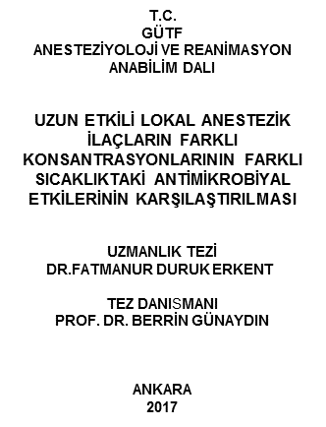 | Antimicrobial Activity of Long Acting Local Anaesthetics.  Duruk Erkent F, Gunaydin B, Erdogan M, Kalkanci A | Presented as a poster at the 51st Annual Meeting of Turkish Society of Anesthesiology & Reanimation in Antalya, Turkey, 2017.
T.C.  GÜTFANESTEZİYOLOJİ VE REANİMASYON  ANABİLİM DALI  SPİNAL ANESTEZİ İLE SEZARYENLE DOĞUM YAPAN GEBELERDE DURA PONKSİYONU SONRASI GELİŞEN BAŞAĞARISINDA MMPS VE IL6 SEVİYELERİNİN ROLÜ  UZMANLIK TEZİ  DR.MÜKERREM UYSAL  TEZ DANISMANI  PROF. DR. BERRİN GÜNAYDIN  ANKARA  2014 | Can we predict who will complain postspinal headache after cesarean delivery? Role of Matrix metalloproetienases  Supported by Gazi University SBE 01/2014-32 BAP Fund  Uysal M, Gunaydin B. | Presented as a poster at the Euroanaesthesia in Vien, Austria, 2019.
T.C. GÜTF  ANESTEZİYOLOJİ VE REANİMASYON  ANABİLİM DALI  LİPOZOMAL BUPİVAKAİNİN  UZMANLIK TEZİ  DR.AYŞE ÜNAL DÜZLÜ  TEZ DANISMANI  PROF. DR. BERRİN GÜNAYDIN  ANKARA  2012 | The Release Patterns of Liposomal Bupivacaine in The Artificial Cerebrospinal Fluid.  Duzlu AU, Gunaydin B, Şukuroglu MK, Degim IT | Published;  Turk J Anaesthesiol Reanim 2016; 44(1):1-6.  Presented as a poster at the 44th Annual Meeting of SOAP in San Juan, Puerto Rico 2013.
T.C. GÜTF  ANESTEZİYOLOJİ VE REANİMASYON ANABİLİM DALI  SIÇANLARDA NÖRAKSİYEL UYGULANAN LİPOZOMAL BUPİVAKAİNİN KONTROLLÜ SALINIM PATERNLERİ  UZMANLIK TEZİ  DR.İLKER YİĞİT  TEZ DANISMANI  PROF. DR. BERRİN GÜNAYDIN  ANKARA  2014 | Controlled Release Patterns of Liposomal Bupivacaine After Neuraxial Administration in Rats.  Yigit I, Gunaydin B, Emmez OH, Uludag O, Bal NB, Degim IT. | Presented as a poster at the 45th Annual Meeting of SOAP in Toronto, Canada, 2014 .
T.C.  GÜTF  ANESTEZİYOLOJİ VE REANİMASYON  ANABİLİM DALI  SEZARYENLERDE OTURUR VE YAN POZİSYONDA UYGULANAN KSE ANESTEZİNİN KARŞILAŞTIRILMASI  UZMANLIK TEZİ  DR.ECE DUMANLAR TAN  TEZ DANISMANI  DOÇ. DR. BERRİN GÜNAYDIN  ANKARA  2007 | Comparison of Maternal And Neonatal Effects of CSE Anaesthesia in Either at The Sitting or Lateral Position During Elective CS.  Tan Dumanlar E, Gunaydin B. | Published;  Turk J Anaesthesiol Reanim 2014;42:23-32.
T.C.  GÜTF  ANESTEZİYOLOJİ VE REANİMASYON  ANABİLİM DALI  ELEKTİF SEZARYENLERDE ANESTEZİDEN DOĞUMA KADAR GEÇEN SÜRELERİN YENİDOĞANA ETKİLERİNİN RETROSPEKTİF OLARAK DEĞERLENDİRLMESİ  UZMANLIK TEZİ  DR.NEJLA MENDİL ERDOĞAN  TEZ DANISMANI  PROF. DR. BERRİN GÜNAYDIN  ANKARA  2012 | The Retrospective Evaluation of the Effects of the Delivery Time Intervals on the Newborn During Elective CS Under Spinal Anesthesia.  Mendil Erdogan N, Gunaydin B, Dikmen AU, Bayram M, Ergenekon E. | Published:  Int J Gynecol Obstet Res 2013; 1:12-16.
T.C.  GÜTF  ANESTEZİYOLOJİ VE REANİMASYON  ANABİLİM DALI  JİNEKOLOJİK LAPAROSKOPİK CERRAHİDE SEREBRAL OKSİMETER KULLANIMI ÖNEMİ  UZMANLIK TEZİ  DR.SEHER EROL  TEZ DANISMANI  PROF. DR. BERRİN GÜNAYDIN  ANKARA  2010 | Use of Cerebral Oximeter During Laparoscopic Gynecologic Surgery.  Erol S, Gunaydin B. | Published;  Gazi Med J 2012; 23:126-32.
T.C.  GÜTF  ANESTEZİYOLOJİ VE REANİMASYON  ANABİLİM DALI  SIÇANLARDA İZOFLURANIN APAPTOTİK ETKİSİNDE DANTROLEN VE KETAMİNİN ROLÜ  UZMANLIK TEZİ  DR.SEYFİ KARTAL  TEZ DANISMANI  PROF. DR. BERRİN GÜNAYDIN  ANKARA  2011 | Role of Ketamine and Dantrolen on the Apoptotic Effect of Isoflurane in Rats.  Kartal S, Gunaydin B, Barun S, Elmas C.  Supported by The Scientific and Technological Research Council of Turkey (TUBİTAK) Project NO:110s514 | Presented as a free paper at 45th Annual Meeting of Turkish Society of Anesthesiology and Reanimation in Antalya, Turkey, 2011.
T.C. GÜTF  ANESTEZİYOLOJİ VE REANİMASYON  ANABİLİM DALI  SPİNAL ANESTEZİ YAPILAN ELEKTİF SEZARYENLERDE FARKLI MİKTARLARDA KRİSTALLOİD ÖNYÜKLEMESİNİN MATERNAL VE NEONATAL ETKİLERİNİN KARŞILAŞTIRILMASI  UZMANLIK TEZİ  DR.FATMA FAYDACI  TEZ DANISMANI  PROF. DR. BERRİN GÜNAYDIN  ANKARA  2009 | Different Preloading Protocols With Constant Ephedrine Infusion in the Prevention of Hypotension for Elective CS Under Spinal Anesthesia.  Faydacı F, Gunaydin B. | Published;  Acta Anesthesiol Belg 2011:62:5-10.
T.C. GÜTF  ANESTEZİYOLOJİ VE REANİMASYON  ANABİLİM DALI  SEZARYEN OPERASYONLARINDA İNTRATEKAL İZOBARİK ROPİVAKAİN VE BUPİVAKAİN KULLANIMININ KARŞILAŞTIRILMASI  UZMANLIK TEZİ  DR.NURAY CAMGÖZ ERYILMAZ  TEZ DANISMANI  DOÇ. DR. BERRİN GÜNAYDIN  ANKARA  2008 | A Comparison of the Effects of Intrathecal Ropivacaine and Bupivacaine During CS.  Camgoz Eryilmaz N, Gunaydin B | Published;  Turk J Med Sci 2011; 41(2): 219-226.
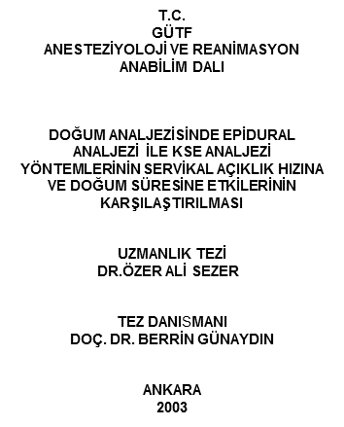 | Efficacy of Patient-Controlled Epidural Analgesia After Initiation With Epidural or CSE Analgesia.  Sezer AO, Gunaydin B | Published;  Int J Obstet Anesth 2007;16(3):226-30.
T.C.  GÜTF  ANESTEZİYOLOJİ VE REANİMASYON  ANABİLİM DALI  FARKLI DOZLARDA DEKSMEDETOMİDİNİN LARİNGOSKOPİ VE ENDOTRAKEAL ENTÜBASYONA KARŞI OLUŞAN HEMODİNAMİK YANITA, PEROPERATUAR ANESTEZİK GEREKSİNİMİNE VE DERLENMEYE ETKİLERİNİN KARŞILAŞTIRILMASI  UZMANLIK TEZİ  DR.AYŞEGÜL KORDAN  TEZ DANISMANI  DOÇ. DR. BERRİN GÜNAYDIN  ANKARA  2005 | Comparison of Effects of Different Doses of Dexmedetomidine on Hemodynamic Responses to Laryngoscopy and Endotracheal Intubation, Peroperative Anesthetic Requirement and Recovery.  Kordan A & Gunaydin B | Published;  Turkish Journal of Anesthesia 2006; 14:95-102.

Scientific Works (detailed bibliography attached):
- 95 Publications in peer-reviewed journals
- More than 60 publications in national peer reviewed journals.
- Editor of 4 books
- 13 book chapters

INVITED SPEAKER AT THE INTERNATIONAL CONFERENCES
Faculty positions at Euroanaesthesia
- (2015) The Pregnant Patient and Hepatic Disease at the 10th Euroanaesthesia in Berlin, Germany.
- (2018) Preeclampsia Scenario with Eclampsia and HELLP Complications at Euroanaesthesia 2018 in Copenhagen, Denmark.
- (2022) Special Trauma Session: Pregnant Trauma Patient Euroanaesthesia in Milan, Italy.

Faculty positions at World Congresses and Anesthesiology Societies’ Meetings
- (2008) Hazards of Topical Drug Administration at the 2nd World Congress of Ophthalmic Anesthesia (WCOA) in Cairo, Egypt.
- (2009) An update on labor analgesia at the 9th World Congress of Perinatal Medicine in Berlin, Germany.
- (2010 & 2011) Non-obstetric Surgery During Pregnancy at the 2nd and 3rd International Symposium on Obstetric Anesthesia and Perinatal Medicine in Poznan, Poland.
- (2012) Master Workshop “CORE” Training : Combined Obstetric Resuscitation and Emergencies – Lecture and Hands on Drill Station: Maternal Collapse and Resuscitation at III New World Anesthesia Convention (NWAC) in İstanbul, Turkey.
- (2013) Master Workshop “CORE” Training : Combined Obstetric Resuscitation and Emergencies – Lecture and Hands on Drill Station: Maternal Collapse due to High Block at the 3rd World Congress of Regional Anesthesia and Pain Therapy (WCRAPT) in Sydney, Australia.
- (2013) Enlightening Women about Labor Pain Relief at the 3rd WCRAPT in Sydney, Australia.
- (2014) Management of Postdural Puncture Headache in the Obstetric and Enlightening Women about Labor Pain Relief at the 4th WCRAPT in Cape Town, South Africa.
- (2015) Practical Approaches to crisis management in obstetric anesthesia and Enlightening Women about Labor Pain Relief in Turkey at the 35th Pakistan Society of Anesthesiology (PSA) in Karachi, Pakistan.
- (2015) Management of a Patient with Abnormal Placentation at the 34th Annual Congress of ESRA (European Society of Regional Anesthesiology) in Ljubljana, Slovenia.
- (2016) Management of Abnormal Placentation & Pregnancy induced hepatic disease at the 13th International Annual Meeting of Indonesian Society of Obstetric Anesthesia, Regional Anesthesia and Pain Medicine in Jakarta, Indonesia.
- (2016) Liver Disease Unique to Pregnancy at the GOAL (Group of Obstetric Anaesthtetists in London) Meeting organized by Royal College of Anaesthetists in London, UK.
- (2017) Pregnancy induced hepatic disease at the 1st World Congress on Obstetric Anesthesia (WCOA) in Bali, Indonesia.
- (2017) Master Workshop PPH Firedrills at the 1st WCOA in Bali, Indonesia.
- (2017) Anesthetic Considerations for Diseases Unique to Pregnancy at the Monatliches Symposium in Anästhesiologie, Intensivmedizin und Reanimatologie in Zurich, Switzerland.
- (2020) Advances in neuraxial labor analgesia modalities: Focus on Dural Puncture Epidural at the 7th Japanese Society of Regional Anesthesia (JSRA) - Online Symposium
- (2021) Management of PPH at the Balkan Anesthesia Days VII: Innovations in Anesthesia Intensive Care&Pain during COVID 19 Pandemic Era, May 2021. Online Congress
- (2022) Trauma in the pregnant patient at the SAESP Brasil 2022- Online Symposium
- (2023) Bleeding management in obstetrics: anesthesiology perspective (Session: OBSTETRICS) at Sao Paulo Congress of Anesthesiology (COPA) in Brasil.
- (2023) Patient Care Centered Interdisplinary Team Approaches: PBM (Session: HOT TOPICS) at Sao Paulo Congress of Anesthesiology (COPA) in Brasil.
- (2023) Management of pregnant trauma patient in the context of global anesthesia at Sao Paulo Congress of Anesthesiology (COPA) in Brasil.

INVITED SPEAKER/MODERATOR AT THE NATIONAL CONFERENCES
Faculty positions at Annual Meetings of Turkish Society of Anesthesiology & Reanimation (TSAR)
- (2007) Physiology of Glucocorticoids, Mineralocorticoids and Androgens at the 41st Annual Congress of TSAR, Antalya, Turkey (TR).
- (2008) Anesthesia for Non-Elective Cesarean Sections at the 42nd Annual Congress of TSAR, Antalya, TR.
- (2009) Effects of Anesthetics and Analgesics on the newborn at the 43rd Annual Congress of TSAR in Antalya, TR.
- (2010) Poster Discussion for Obstetric Anesthesia at the 44th Annual Congress of TSAR, Antalya, TR.
- (2011) Refresher Course: Uterotonics at the 45th Annual Congress of TSAR in Antalya, TR.
- (2013) Obstetric Anesthesia Issues for “Aged Mothers” at the 47th Annual Congress of TSAR, Antalya, TR.
- (2014) Neuraxial Anesthesia for Emergency Cesarean Section at the 48th Annual Congress of TSAR, Ankara, TR.
- (2015) Goal-directed Coagulation Treatment at the 49th Annual Congress of TSAR, Ankara, TR.
- (2016) Pregnancy Induced Liver Diseases at the 50th Annual Congress of TSAR, Istanbul, TR.
- (2017) Moderator: Management of PPH at the 51st Annual Congress of TSAR, Istanbul, TR.
- (2018) IV Patient Controlled Analgesia for Labor at the 52th Annual Congress of TSAR, Antalya, TR.
- (2018) Moderator: State-of-the-art techniques to ensure optimal labor and cesarean delivery analgesia at the 52nd Annual Congress of TSAR, Antalya, TR.
- (2019) Moderator: Either regional or general anesthesia for particular pregnant patients at the 53rd Annual Congress of TSAR, Antalya, TR.
- (2020): Moderator: Patient Blood Management in Obstetrics at the 54th Annual Congress of TSAR, Ankara, TR.
- (2021) Moderator: Fibrinogen and Patient Blood Management: Worldwide and countrywide Developments at the 55th Annual Congress of TSAR, Antalya, TR.
- (2021) Moderator: CPR in the Pregnant woman at the 55th Annual Congress of TSAR, Antalya, TR.
- (2022) Moderator: Combating maternal mortality and morbidity at the 56th Annual Congress of TSAR, Antalya, TR.
- (2022) Moderator: Fibrinogen use in trauma and bleeding surgeries (Satellite Symposium) at the 56th Annual Congress of TSAR, Antalya, TR.
- (2023) Problems and Solutions in the Obstetric Patient: Bleeding Emergencies (PPH) at the 57th Annual Congress of TSAR, Antalya, TR.

Faculty positions at National Regional Anesthesia Meetings
- (2008) Regional Anesthesia for Obstetrics at the IX Regional Anesthesia Meeting in İstanbul, Turkey.
- (2009) Evidence Based Obstetric Regional Anesthesia at the X Regional Anesthesia Meeting, in Istanbul, Turkey.
- (2010) Management of Difficult and Failed Regional Anesthesia in Obstetrics (Problem Based Learning Discussion) at the XI Regional Anesthesia Meeting in İstanbul, Turkey.
- (2010) Practice of Regional Anesthesia for Cesarean Section at the XI Regional Anesthesia Meeting in İstanbul, Turkey.
- (2011) Anesthetic Management for Obstetric Emergencies at the XII Regional Anesthesia Meeting in İstanbul, Turkey.
- (2011) Anesthetic Management of Severe Preeclampsia (Problem Based Learning Discussion) at the XII Regional Anesthesia Meeting in İstanbul, Turkey.
- (2013) Regional Anesthesia Practice for Cesarean Section at the XIII Regional Anesthesia Meeting in İstanbul, Turkey.
Faculty Positons at Other Meetings:
- (2004 & 2006) Medical Chronobiology and its Applications at the 3rd and 4th International Postgraduate Educational Courses on Chronobiology and Chronomedicine, Chronobiology and Pain in Cappadocia, Turkey.
- (2007) Prevention Strategy for Postdural Puncture Headache at the VI. International Congress of Orthopedic Anesthesia in İstanbul, Turkey.
- (2008) Ambulatory Anesthesia and Obstetric Anesthesia at the 5th ISOA and ISRA in Jakarta, Indonesia.
- (2009) An update on labor analgesia at the 1st International Symposium on Obstetric Anesthesia and Perinatal Medicine in Poznan, Poland.
- (2009) Labor Pain Relief, Congress of Family Planning Reproductive Medicine in Ankara, Turkey.
- (2009) Current Approaches for Obstetric Regional Anesthesia at Çukurova Anesthesia Days in Adana, Turkey.

NATIONAL MEETINGS ON PERIOPERATIVE HEMATOLOGICAL PROBLEMS AND SOLUTIONS IN BLEEDING SURGICAL PATIENTS ORGANIZED IN 7 BRANCHES OF TURKISH SOCIETY OF ANESTHESIOLOGY AND REANIMATION (TSAR). Available at http://www.tard.org.tr/assets/pdf/ankaraprogram.pdf

Region/Branch of TSAR | City - Date
Black Sea | Trabzon - 18.11.2017
Center | Istanbul - 02.12.2017
Marmara | Bursa - 07.01.2018
Cukurova | Adana - 13.01.208
Central Anatolia, Chair: Berrin Gunaydin | Ankara - 10.02.2018
Dicle-Firat, Chair: Berrin Gunaydin | Diyarbakır - 24.12.2018
Agean and Mediterranean | Izmir - 10.03.2018

Available at http://www.websitem.gazi.edu.tr/site/gunaydin/posts/view/id/109254

International Multi/Interdisciplinary Courses With Non-Profit Organizations ( www.giganode.org)
Educational Activities on Mother and Child: PBM & PPH Management
- As a course director
- (2019) Multidisciplinary Approach in Bleeding Management in Obstetrics and Cardiac Surgery: Focus on Anemia/Iron Deficiency organized by EurAsia Heart Foundation, Hainburg, Austria, May 26-31, 2019.
- (2019) Interdisciplinary Meeting on Perioperative Bleeding Management and Patient Blood Management (PBM) in `Mother and Child` by EurAsia Heart Foundation & Heart Team Education Association, Ankara, Turkey, December 7, 2019.
- (2022) Perioperative Medicine (POM): Focus on Mother and Child: POM in Obstetrics/Gynecology + Pediatrics by EurAsia Heart Foundation & Heart Team Education Association, Salzburg, Austria, February 20-25, 2022.
https://www.giganode.org/upcoming-and-previous-webinars-and-events/
- As a speaker
- (2019) ‘Bleeding Management in Obstetrics: General Measures ‘ at the Interdisciplinary Meeting on Bleeding Management in Cardiac Surgery and Obstetrics organized by EurAsia Heart Foundation, Cesme-Izmir, Turkey, April 15-19, 2019.
- (2019) ‘PBM: Anemia prevention before surgery-Preoperative Evaluation in Pregnancy at the Multidisciplinary Approach in Bleeding Management in Obstetrics and Cardiac Surgery: Focus on Anemia/Iron Deficiency organized by EurAsia Heart Foundation, Hainburg, Austria, May 26-31, 2019.)
- (2019) Bleeding Management in PPH: Anesthesiology Perspective’ at the Multidisciplinary Approach in Bleeding Management in Obstetrics and Cardiac Surgery: Focus on Anemia/Iron Deficiency organized by EurAsia Heart Foundation, Hainburg, Austria, May 26-31, 2019.)
- (2019) Management of PPH: Which Fluid? Which Hemostatic Agent? Which Blood/Blood Products? at the Interdisciplinary Meeting on Perioperative Bleeding Management and Patient Blood Management in `Mother and Child` by EurAsia Heart Foundation & Heart Team Education Association, Ankara, Turkey, December 7, 2019.
- (2019) Preoperative Evaluation of Anemia for Obstetric Anesthesia at the Interdisciplinary Meeting on Perioperative Bleeding Management and PBM in `Mother and Child` by EurAsia Heart Foundation & Heart Team Education Association, Ankara, Turkey, December 7, 2019.
- (2020) General management of PPH: Focus on New Maternity and Obstetric Guidelines in Turkey, Webinar, Ankara.
- (2020) Interdisciplinary Approach in Bleeding Situations: POB/PBM in Mother and Child: Bleeding Management in PPH, Webinar, Salzburg.
- (2021) Fibrinogen testing in Obstetrics: What options do we have? Webinar, Ankara.
- (2021) Management of Bleeding in Obstetrics Anesthesiology Perspective, Webinar, 2nd Interdisciplinary Seminar: Basics hemodynamics, hypoperfusion, coagulation activation, DIC, Moldova.

Education program and material development at national level
Along with national PBM strategic action plan, evidence based PBM guidelines/modules for 6 different medical specialization fields were prepared with contribution of 22 relevant national societies of surgical/internal medicine. Of note, PBM Guideline for Maternity & Obstetrics was prepared under Dr Gunaydin’s leadership. After a countrywide 1123 surveys that indicated PBM education need, 3,130 physicians involved in blood transfusion were trained online (2 day-long PBM Basics & interactive case scenarios during a 3-month period) by 75 professional physicians. Dr.Gunaydin has been one of the instructors. Transfusion medicine curriculum was updated in colloboration with Higher Education Board and Medical Specialists Board to add as a new curriculum. A PBM software developed to improve quality and safety of transfusion was uploaded to pilot government hospitals under Turkish Ministry of Health which has been a milestone in our country as part of the EU-Turkey project entitled Technical Assistance for Improving the Blood Transfusion Management System in Turkey.

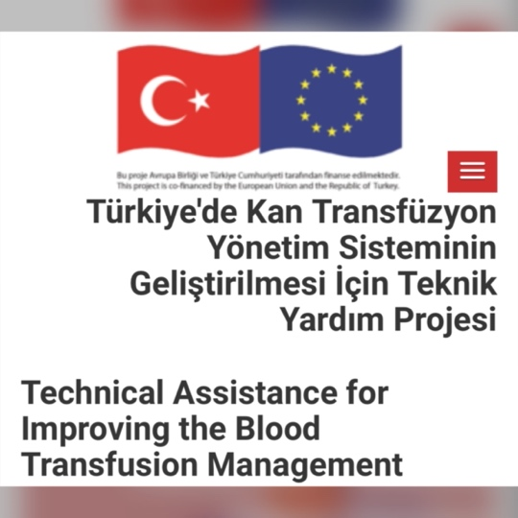

- 22 National Societies contributed
- 6 Guidelines launched recently (January 2023)
Between March 20, 2019- March 20, 2022
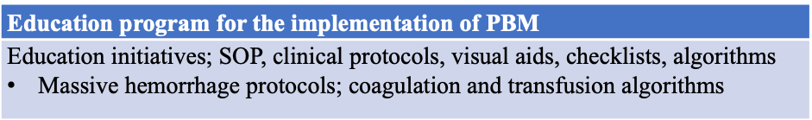
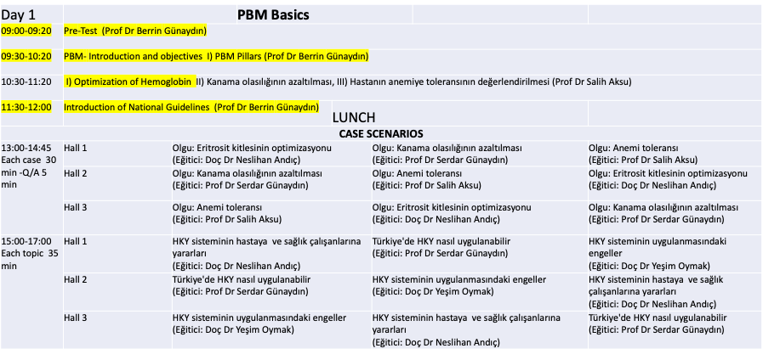
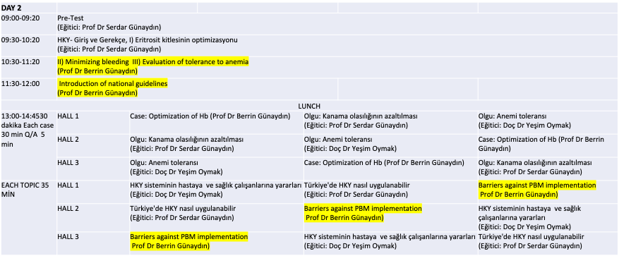

• Editor of Patient Blood Management (PBM )Guideline on Maternity and Obstetrics (Module V). The online material has been launched in January 2023 at;
https://shgmkanhizmetleridb.saglik.gov. tr/Eklenti/44850/0/5-hasta-kanyonetimi-
rehberi-modul-5---gebelik-vedogumpdf.pdf
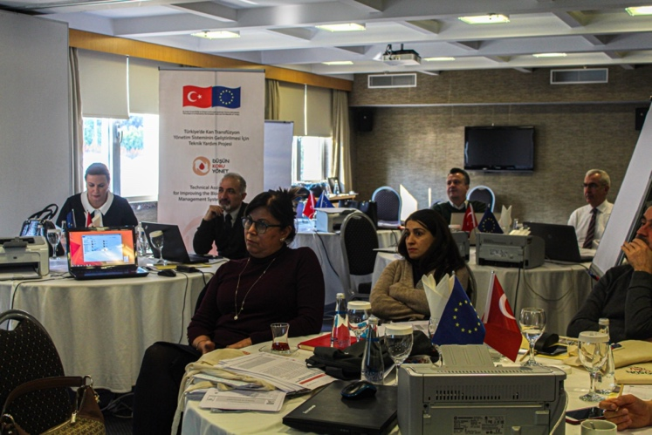
PBM Guideline preparation team
Demonstrated medical volunteerism
RUN FOR PEACE-Turkcell Gelibolu Marathon, 2015 (10 K 1:00:12 hr, 1st place age category) 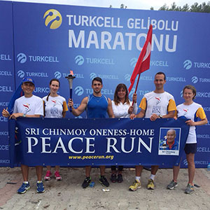
RUN FOR WHO CANNOT RUN-SPINAL CORD RESEARCH Wings for life World Run, İzmir, 2017
Dr. Gunaydin received medals at Medigames and European Veteran Athletics Championship
- 37th World Health & Medical Games (2016), Maribor, Slovenia
400 m (1.33 min) Bronze Medal/1500 m (7.56 min) Bronze Medal
10 Km Cross Country (6th place)
- 36th World Health & Medical Games (2015), Dublin, Irlanda
400 m (1.38 min) Bronze Medal
- 19th EVACS (European Veteran Athletics Championship) 2014, Izmir,
800 m (3.15 min) & 1500 m (7.13 min) Final

MEDIA
Broadcasts for enlightening parturients/mothers about pain relief methods for labor and delivery on TRT (Turkish Radio Television) and other private channels in Health theme programs. Available at http://www.berringunaydin.com/media_en

TRT International Channel, 2007 | 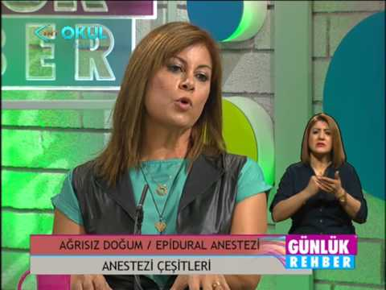  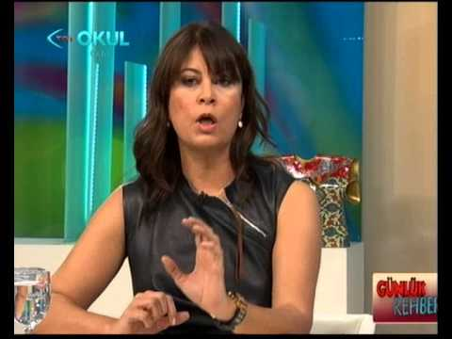  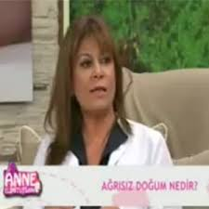  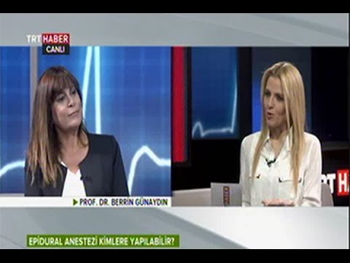  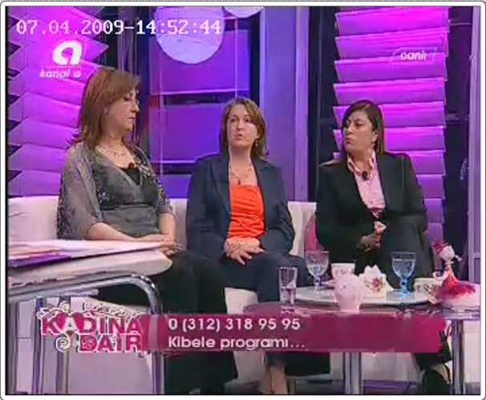
TRT Euro-Asia Channel, 2008

Life TV Channel, 2010

TRT Daily Guide Education, 2012

TRT Euro-Asia Channel - Prescription, 2012

Life Therapy Channel, 2012

TRT 1 Channel - Hold my hand mom, 2013

TRT Daily Guide Education, 2013

TRT News, Q&A on labor & delivery, 2015

TRT Euro-Asia – Life is beautiful, 2017

